Aim: Write a Program to swap two values with third Variable using JAVA.

Program :

import java.io.\*;

class swap

{

public static void main(String args[])

{

int a=10,b=20,c;

System.out.println("before swapping a is :

"+a);

System.out.println("before swapping b is :

"+b);

c=a;

a=b;

b=c;

System.out.println("after swapping a is : "+a);

System.out.println("after swapping b is : "+b);

}

}

Output :

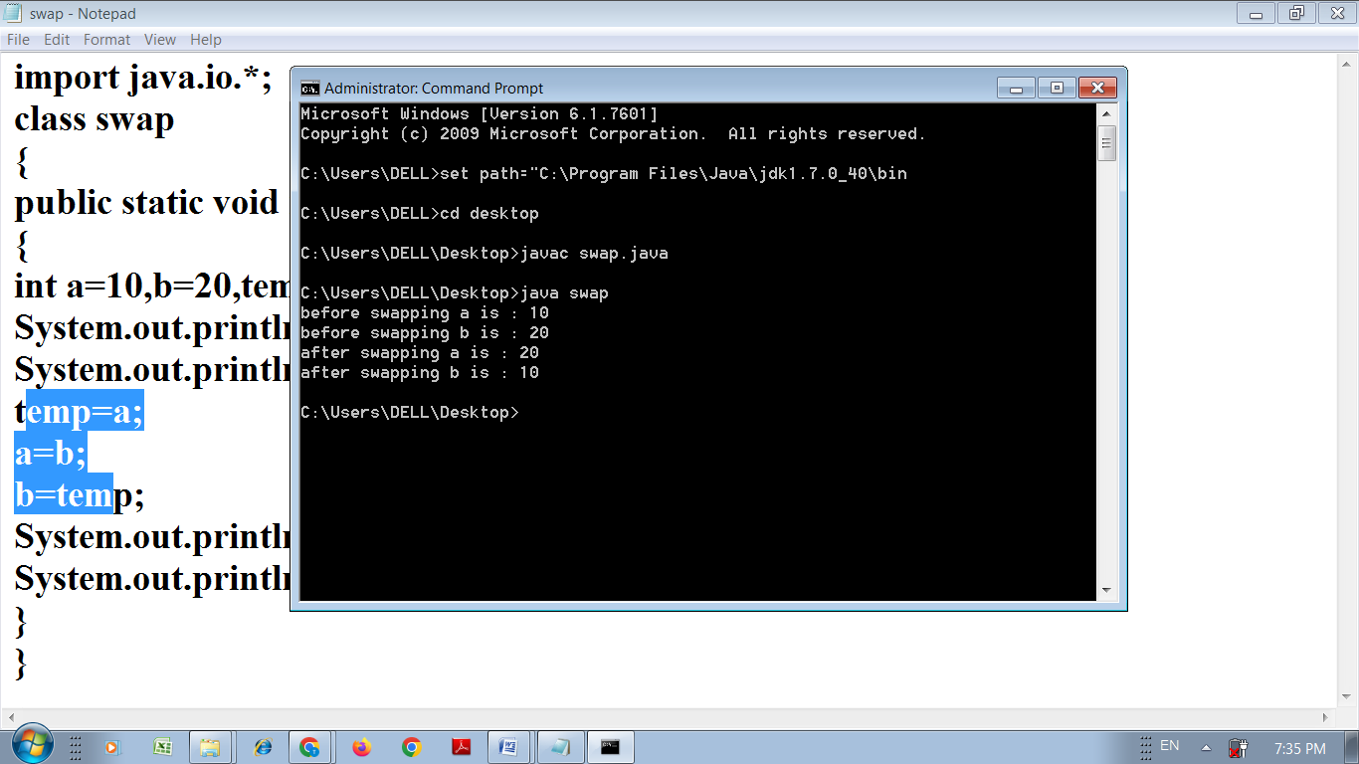

Aim: Write a Program to swap two user accepted values with third Variable using JAVA.

import java.io.\*;

import java.util.\*;

class swap

{

public static void main(String args[])

{

Scanner s=new Scanner(System.in);

int a,b,c;

System.out.println("Enter the value of A ");

a=s.nextInt();

System.out.println("Enter the value of B ");

b=s.nextInt();

System.out.println("before swapping a is : "+a);

System.out.println("before swapping b is : "+b);

c=a;

a=b;

b=c;

System.out.println("after swapping a is : "+a);

System.out.println("after swapping b is : "+b);

}

}

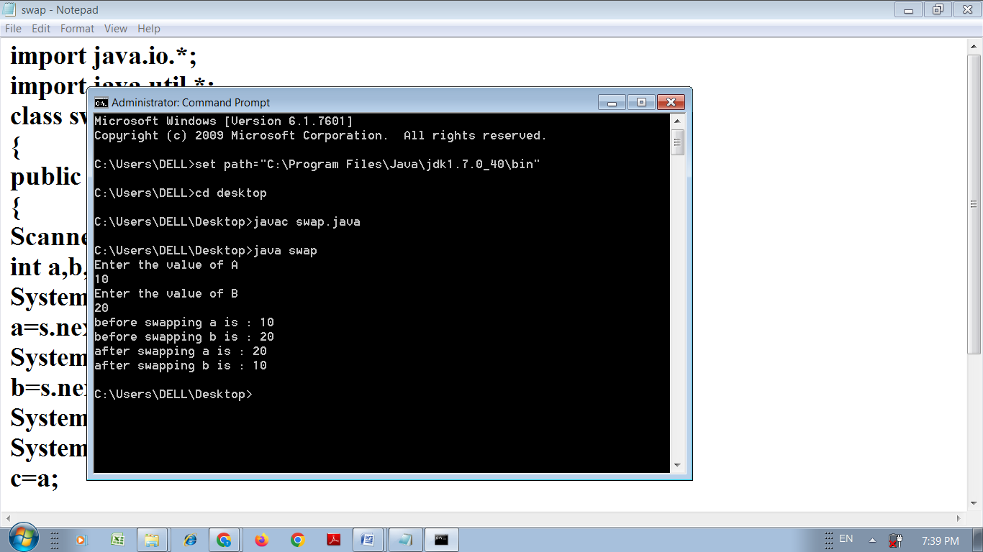

Aim: Write a Program to swap two user accepted values without third Variable using JAVA.

import java.io.\*;

import java.util.\*;

class swap

{

public static void main(String args[])

{

Scanner s=new Scanner(System.in);

int a,b;

System.out.println("Enter the value of A ");

a=s.nextInt();

System.out.println("Enter the value of B ");

b=s.nextInt();

System.out.println("before swapping a is : "+a);

System.out.println("before swapping b is : "+b);

a=a+b;

b=a-b;

a=a-b;

System.out.println("after swapping a is : "+a);

System.out.println("after swapping b is : "+b);

}

}

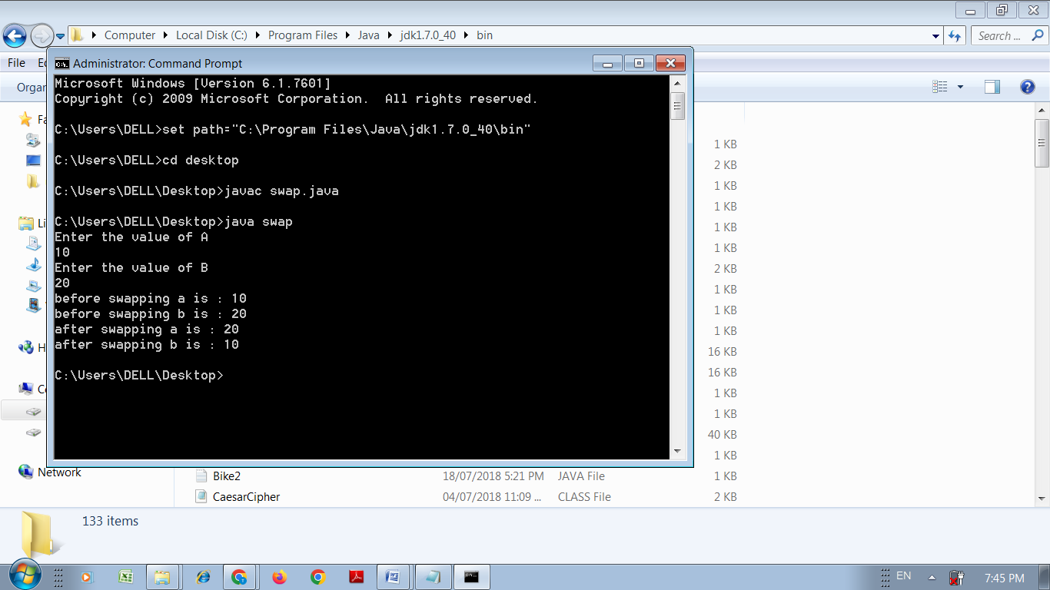

Aim: Write a Program to reverse a number of user accepted number using JAVA.

import java.util.\*;

public class test

{

public static void main(String[] args)

{

Scanner s=new Scanner(System.in);

int number, reverse = 0;

System.out.println("Enter the value to reverse ");

number=s.nextInt();

while(number != 0)

{

int remainder = number % 10;

reverse = reverse \* 10 + remainder;

number = number/10;

}

System.out.println("The reverse of the given number is: " + reverse);

}

}

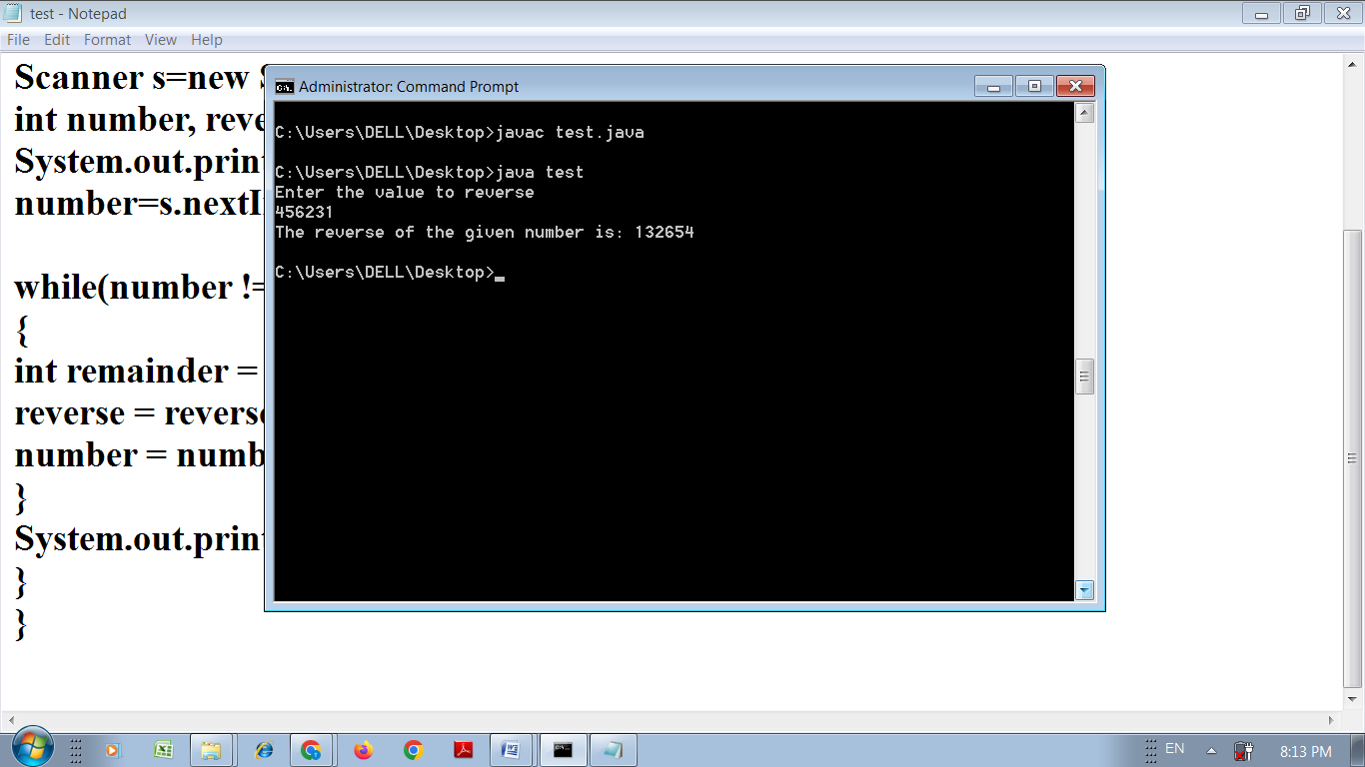

Aim: Write a Program to reverse a number using JAVA.

public class test

{

public static void main(String[] args)

{

int number = 987654, reverse = 0;

while(number != 0)

{

int remainder = number % 10;

reverse = reverse \* 10 + remainder;

number = number/10;

}

System.out.println("The reverse of the given number is: " + reverse);

}

}

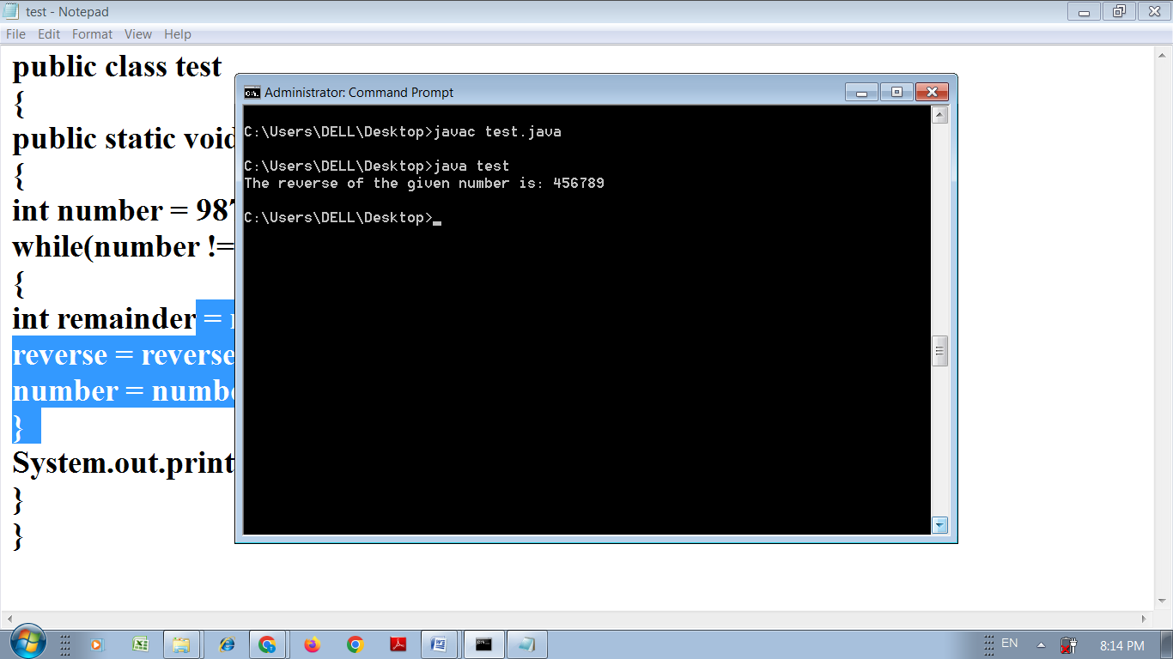

Aim: Write a Program to generate Fibonacci series using JAVA.

class test{

public static void main(String args[])

{

int n1=0,n2=1,n3,i,count=100;

System.out.print(n1+" "+n2);//printing 0 and 1

for(i=2;i<count;++i)//loop starts from 2 because 0 and 1 are already

printed

{

n3=n1+n2;

System.out.print(" "+n3);

n1=n2;

n2=n3;

}

}}

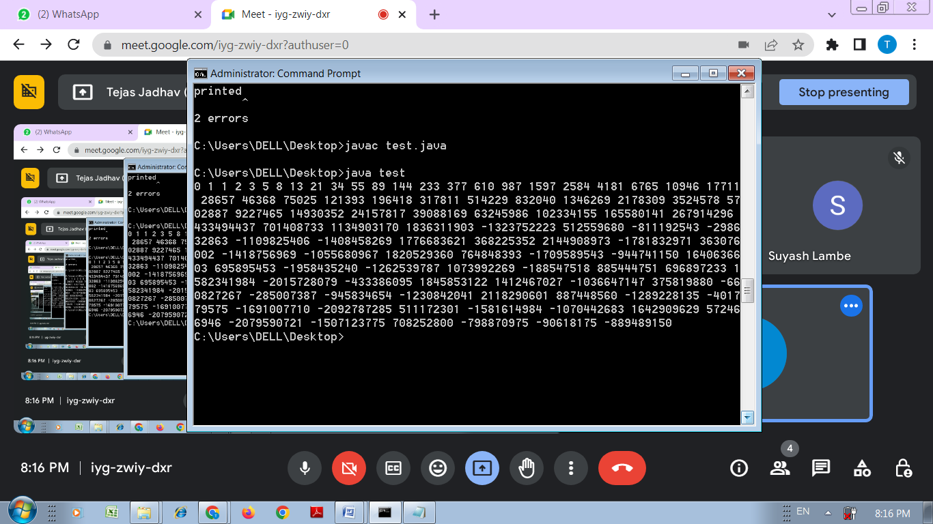

Aim: Write a Program to find given number is prime or not of user accepted value using JAVA.

public class test

{

public static void main(String args[])

{

int i,m=0,flag=0;

int n=5;//it is the number to be checked

m=n/2;

if(n==0||n==1){

System.out.println(n+" is not prime number");

}

else

{

for(i=2;i<=m;i++){

if(n%i==0){

System.out.println(n+" is not prime number");

flag=1;

break;

}

}

if(flag==0) { System.out.println(n+" is prime number"); }

}//end of else

}

}

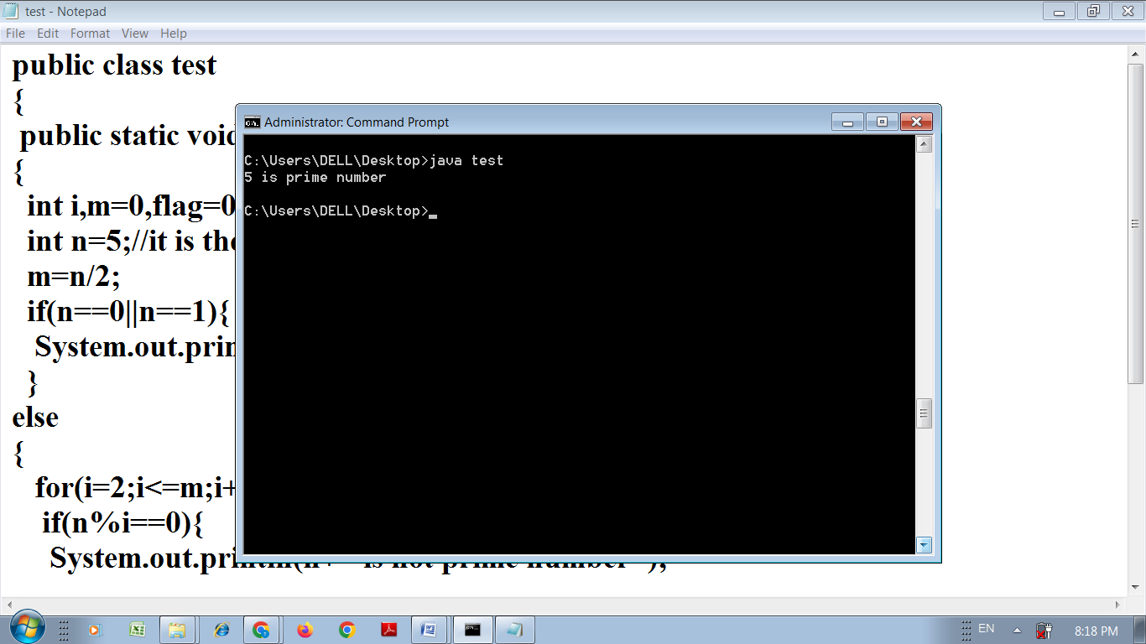

Aim: Write a Program to find given number is prime or not using JAVA.

import java.util.\*;

public class test

{

public static void main(String args[])

{

Scanner s=new Scanner(System.in);

int i,m=0,flag=0;

System.out.println("Enter the no to find prime or not ");

int n=s.nextInt();;

m=n/2;

if(n==0||n==1)

{

System.out.println(n+" is not prime number");

}

else

{

for(i=2;i<=m;i++){

if(n%i==0){

System.out.println(n+" is not prime number");

flag=1;

break;

}

}

if(flag==0)

{

System.out.println(n+" is prime number"); }

}//end of else

}

}

Aim: Write a Program to Demonstrate different Patterns using JAVA.

class test

{

public static void main(String[] args)

{

int i,j;

for(i=1; i<=6; i++)

{

for(j=1; j<i; j++)

{

System.out.print("\*");

}

System.out.println();

}

}

}

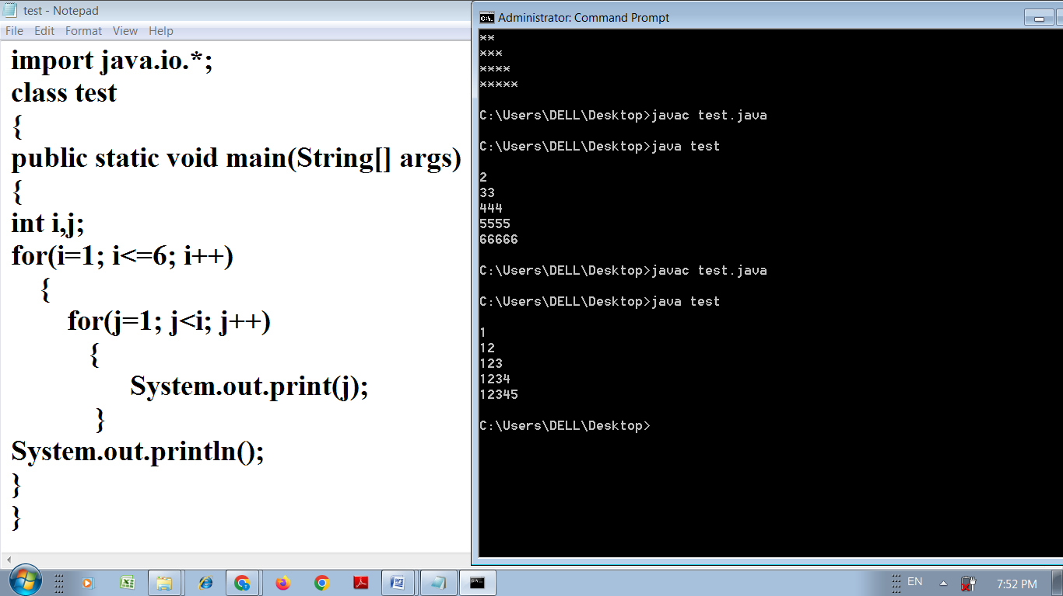

// for more patterns <https://www.javatpoint.com/how-to-print-pattern-in-java>

Aim: Write a Program to find area and Perimeter of Circle using JAVA.

public class test

{

public static void main(String[] args)

{

double radius = 7.5;

double perimeter = 2 \* Math.PI \* radius;

double area = Math.PI \* radius \* radius;

System.out.println("Perimeter is = " + perimeter);

System.out.println("Area is = " + area);

}

}

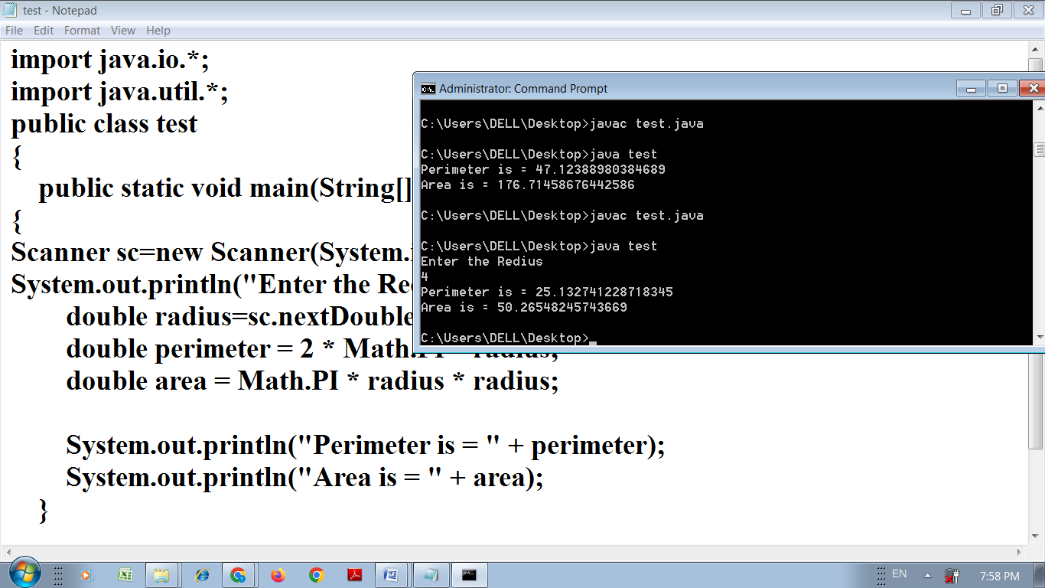

Aim: Write a Program to find area and Perimeter of Circle of user accepted value using JAVA.

import java.util.\*;

public class test

{

public static void main(String[] args)

{

Scanner sc=new Scanner(System.in);

System.out.println("Enter the Radius = " );

double radius =sc.nextDouble();

double perimeter = 2 \* Math.PI \* radius;

double area = Math.PI \* radius \* radius;

System.out.println("Perimeter is = " + perimeter);

System.out.println("Area is = " + area);

}

}



Aim: Write a Program to find area of Rectangle using JAVA.

public class test

{

public static void main(String args[])

{

int width=5;

int height=10;

int area=width\*height;

System.out.println("Area of rectangle="+area);

}

}

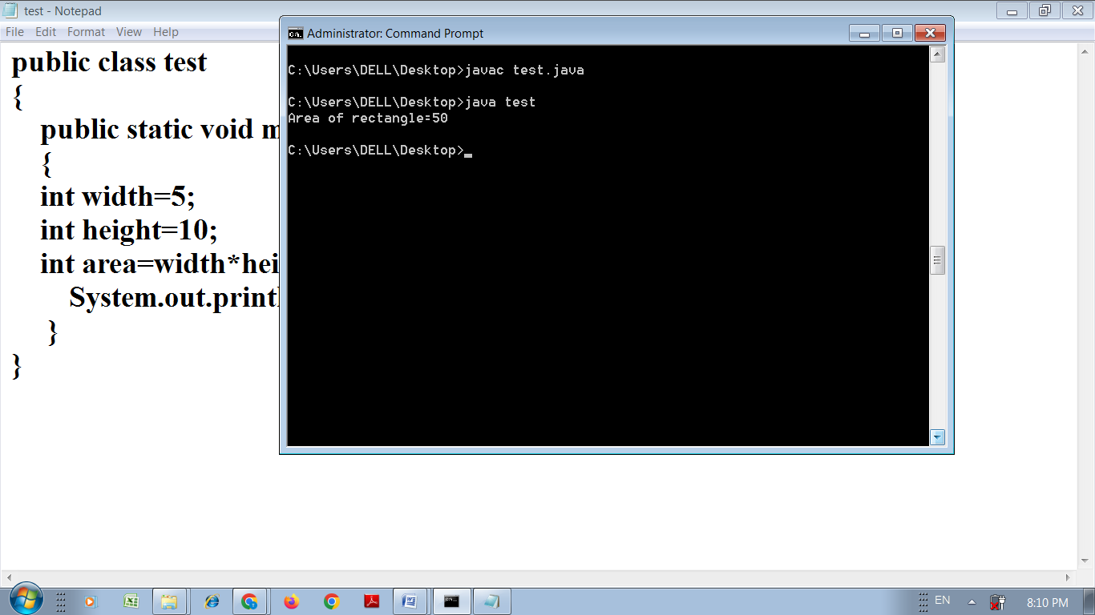

Aim: Write a Program to demonstrate Matrix Multiplication using JAVA.

import java.util.Scanner;

class test

{

public static void main(String args[])

{

int m, n, p, q, sum = 0, c, d, k;

Scanner in = new Scanner(System.in);

System.out.println("Enter the number of rows and columns of first matrix");

m = in.nextInt();

n = in.nextInt();

int first[][] = new int[m][n];

System.out.println("Enter the elements of first matrix");

for ( c = 0 ; c < m ; c++ )

for ( d = 0 ; d < n ; d++ )

first[c][d] = in.nextInt();

System.out.println("Enter the number of rows and columns of second matrix");

p = in.nextInt();

q = in.nextInt();

if ( n != p )

System.out.println("Matrices with entered orders can't be multiplied with

each other.");

else

{

int second[][] = new int[p][q];

int multiply[][] = new int[m][q];

System.out.println("Enter the elements of second matrix");

for ( c = 0 ; c < p ; c++ )

for ( d = 0 ; d < q ; d++ )

second[c][d] = in.nextInt();

for ( c = 0 ; c < m ; c++ )

{

for ( d = 0 ; d < q ; d++ )

{

for ( k = 0 ; k < p ; k++ )

{

sum = sum + first[c][k]\*second[k][d];

}

multiply[c][d] = sum;

sum = 0;

}

}

System.out.println("Product of entered matrices:-");

for ( c = 0 ; c < m ; c++ )

{

for ( d = 0 ; d < q ; d++ )

System.out.print(multiply[c][d]+"\t");

System.out.print("\n");

}

}

}

}

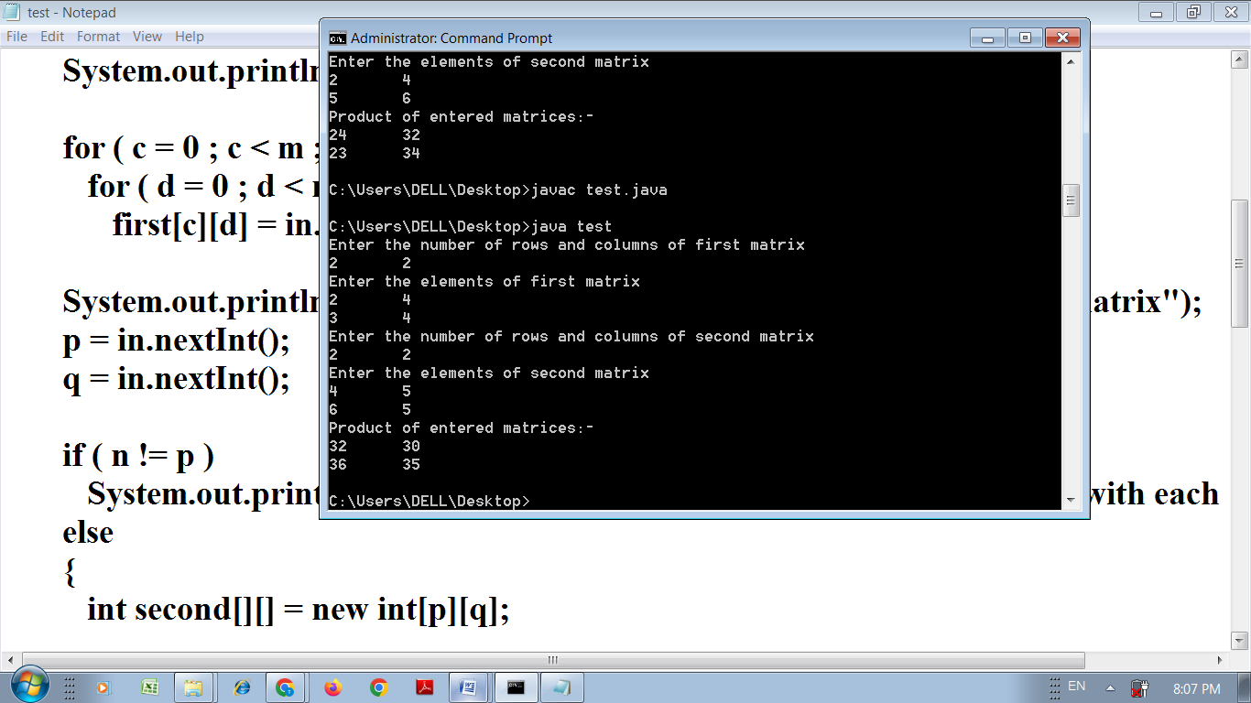

Aim: Write a Program to demonstrate Inhetitance using JAVA.

class test1

{

static int num1=10;

static int num2=5;

}

class test extends test1

{

public static void main(String[] args)

{

int num3=2;

int result=num1+num2+num3;

System.out.println("Result of child class is "+result);

}

}

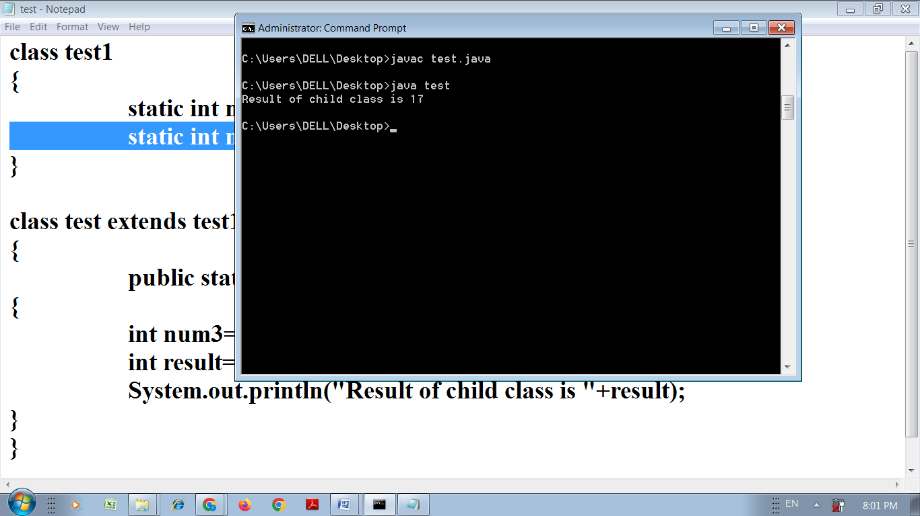

Aim: Write a Program to demonstrate Interface Concept using JAVA.

interface Car

{

int speed=60;

public void distanceTravelled();

}

interface Bus

{

int distance=100;

public void speed();

}

public class test implements Car,Bus

{

int distanceTravelled;

int averageSpeed;

public void distanceTravelled()

{

distanceTravelled=speed\*distance;

System.out.println("Total Distance Travelled is : "+distanceTravelled);

}

public void speed()

{

int averageSpeed=distanceTravelled/speed;

System.out.println("Average Speed maintained is : "+averageSpeed);

}

public static void main(String args[])

{

test t1=new test();

t1.distanceTravelled();

t1.speed();

}

}

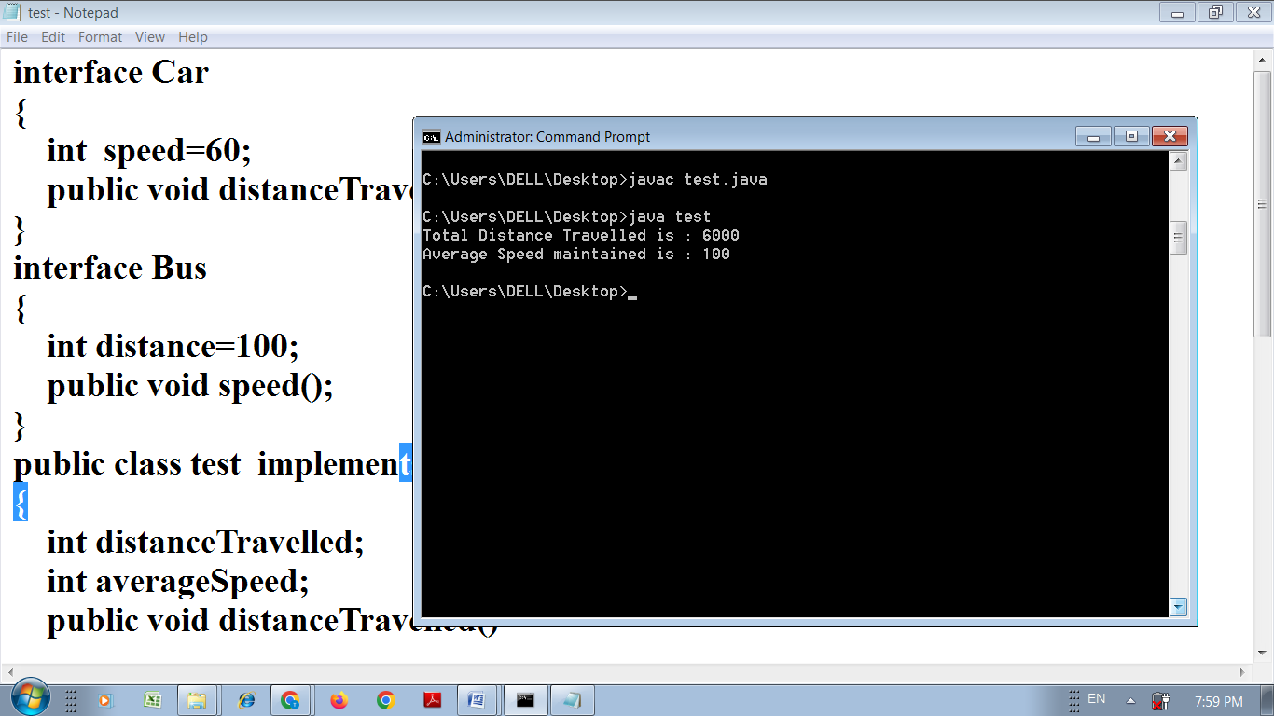

Aim: Write a Program to demonstrate Garbage Collection using JAVA.

class test

{

test()

{

System.out.println("Hello");

}

public static void main(String args[])

{

test t1=new test();

t1=null;

System.gc();

}

public void finalize()

{

System.out.println("Destroyed");

}

}

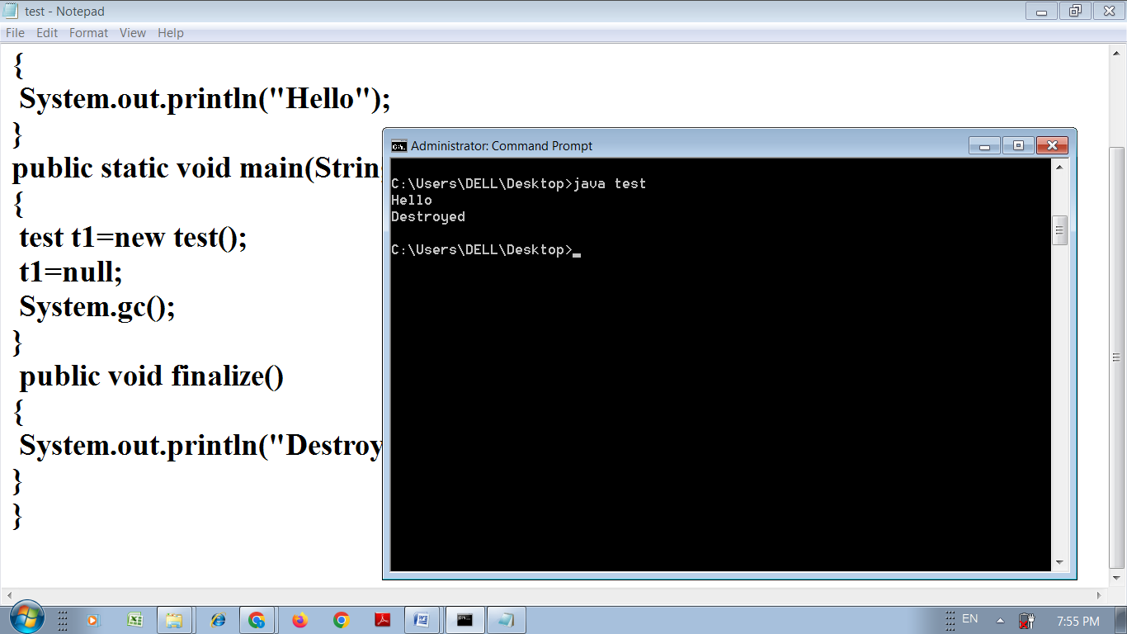

Aim: Write a Program to demonstrate Method Overriding using JAVA.

class Human

{

//Overridden method

public void eat()

{

System.out.println("Human is eating");

}

}

class Boy extends Human{

//Overriding method

public void eat()

{

System.out.println("Boy is eating");

}

public static void main( String args[])

{

Boy obj = new Boy();

//This will call the child class version of eat()

obj.eat();

}

}

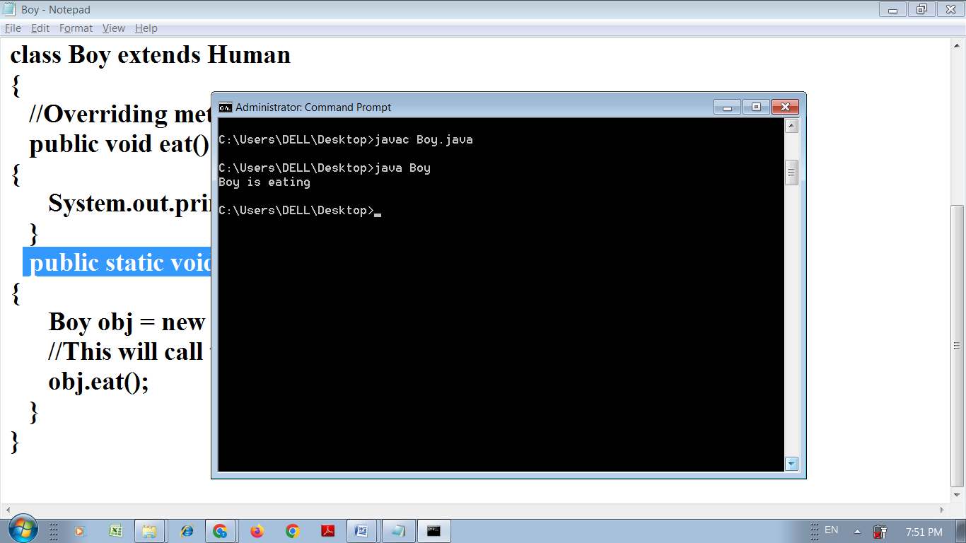

Aim: Write a Program to demonstrate Exception Handling using JAVA.

class test

{

public static void main(String args[])

{

int a,b,c;

try

{

a=0;

b=10;

c=b/a;

System.out.println("This line will not be executed");

}

catch(ArithmeticException e)

{

System.out.println("Divided by zero");

}

System.out.println("After exception is handled");

}

}

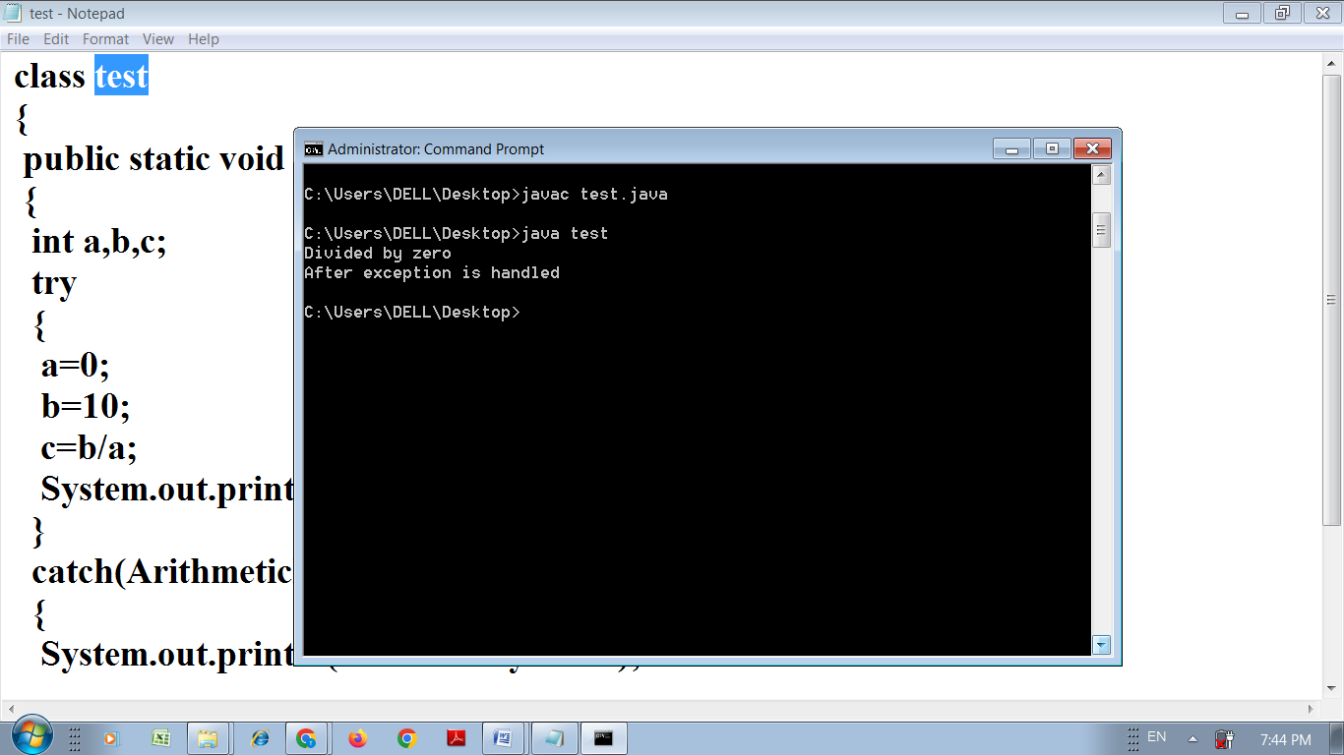

Aim: Write a Program to demonstrate thread using JAVA.

public class test extends Thread {

public void run()

{

System.out.println("Thread is runing !!");

}

public static void main(String[] args)

{

test t1 = new test();

test t2 = new test();

System.out.println("T1 ==> " + t1.getState());

System.out.println("T2 ==> " + t2.getState());

t1.start();

System.out.println("T1 ==> " + t1.getState());

System.out.println("T2 ==> " + t2.getState());

t2.start();

System.out.println("T1 ==> " + t1.getState());

System.out.println("T2 ==> " + t2.getState());

}

}

